IT-SIMPLERA INSTITUTE

Week 2 Task Report
IP Addressing (FLSM & VLSM) and VLAN Configuration Implementation
Registration Number
NETBO1-6898
Submitted By
Iman Nadeem
Company
IT-SIMPLERA Institute
Department
Network Administration
Supervisor
Engr. Jawad Qayum(Senior Network Administrator)
Submission Date
10 July 2026

Executive Summary
This technical report presents the implementation of Fixed Length Subnet Masking (FLSM), Variable Length Subnet Masking (VLSM), and Virtual Local Area Network (VLAN) technologies completed during Week 02 of the Network Administration Internship Program. The main objective of this project is to optimize IP address allocation, reduce address space wastage through subnetting techniques, and establish secure network segmentation using VLANs. As part of this work, 10 FLSM subnetting problems and 5 VLSM design scenarios were completed to develop efficient IP addressing schemes for different network requirements while ensuring scalability and proper utilization of available address space.
The practical implementation was completed and verified using Cisco Packet Tracer and GNS3. A Router-on-a-Stick topology was configured with three VLANs—VLAN 10 (Sales), VLAN 20 (IT), and VLAN 30 (HR)—using the 192.168.1.0/24 network with VLSM-based subnet allocation. Two Layer-2 switches were connected through trunk links, while a Cisco router provided inter-VLAN communication using sub-interfaces. The configuration was verified through VLAN, trunk, and connectivity testing using show commands and ping tests. The successful implementation demonstrates efficient IP address management, secure logical network segmentation, and a scalable network infrastructure suitable for small to medium-sized enterprise environments.
Internship Objectives
- IP Engineering Mastery: Applying Fixed Length Subnet Masking (FLSM) and Variable Length Subnet Masking (VLSM) mathematical frameworks to structure deterministic network boundaries.
- Resource Optimization: Eliminating IPv4 address exhaustion by aligning block allocations strictly with departmental host requirements.
- Traffic Segmentation: Restricting broadcast domains and isolating sensitive departmental data by implementing Virtual Local Area Networks (VLANs).
- Multi-Platform Deployment: Validating cross-environment configuration consistency by replicating topologies across Cisco Packet Tracer and GNS3 emulation platforms.
- Enterprise Verification: Using industry-standard Cisco IOS troubleshooting commands to verify path selection, trunk links, and packet transit success.
Core Technical Overview
FLSM vs. VLSM Paradigm
Fixed Length Subnet Masking (FLSM): Divides a core network block into equal-sized subnets where every segment shares an identical subnet mask. While straightforward to administer, it introduces significant address space wastage when subnets host highly disparate node densities.
Variable Length Subnet Masking (VLSM): Employs a hierarchical design approach where subnet masks vary in length. This allows subnets to match the exact host requirements of individual segments, conserving critical IP assets.
VLAN Infrastructure and Trunks
Virtual Local Area Networks (VLANs): Break down a single physical broadcast domain into multiple logical broadcast domains at Layer 2. This ensures data privacy and limits broadcast storms across the infrastructure.
Access Ports: Switchports configured to carry traffic for a single, specific VLAN destination.
Trunk Ports (IEEE 802.1Q): High-capacity links configured between switches to carry traffic originating from multiple VLANs across a single physical medium.
Subnetting Mechanics & Analysis
Fixed Length Subnet Masking (FLSM) Practical Scenarios
Problem 1: Divide the network 192.168.10.0/24 into 4 equal subnets.
Calculation: To find borrowed bits: 2^n >= 4 => n = 2 bits. New CIDR is /24 + 2 = /26 (Subnet Mask: 255.255.255.192). Magic Number: 256 - 192 = 64.
Subnet | Network ID | First Usable IP | Last Usable IP | Broadcast Address
Subnet 1 | 192.168.10.0 | 192.168.10.1 | 192.168.10.62 | 192.168.10.63
Subnet 2 | 192.168.10.64 | 192.168.10.65 | 192.168.10.126 | 192.168.10.127
Subnet 3 | 192.168.10.128 | 192.168.10.129 | 192.168.10.190 | 192.168.10.191
Subnet 4 | 192.168.10.192 | 192.168.10.193 | 192.168.10.254 | 192.168.10.255

Problem 2: Divide the network 192.168.50.0/24 into 8 equal subnets.
Calculation: Borrowed bits: 2^n >= 8 => n = 3 bits. New CIDR: /27 (Mask: 255.255.255.224). Block size: 32.
Subnet | Network ID | First Usable IP | Last Usable IP | Broadcast Address
Subnet 1 | 192.168.50.0 | 192.168.50.1 | 192.168.50.30 | 192.168.50.31
Subnet 2 | 192.168.50.32 | 192.168.50.33 | 192.168.50.62 | 192.168.50.63
Subnet 3 | 192.168.50.64 | 192.168.50.65 | 192.168.50.94 | 192.168.50.95
Subnet 4 | 192.168.50.96 | 192.168.50.97 | 192.168.50.126 | 192.168.50.127
Implemented VLSM Subnet Architecture
For the live production topology verified in GNS3, a base network block of 192.168.1.0/24 was segmented using Variable Length Subnet Masking (VLSM) to precisely match the sizing requirements of the enterprise departments while establishing optimized gateways on Router R1.
Department / VLAN | Network Address | Subnet Mask | Gateway IP | Usable Host Range | Broadcast Address
VLAN 10 - SALES | 192.168.1.0/26 | 255.255.255.192 | 192.168.1.1 | 192.168.1.2 - .62 | 192.168.1.63
VLAN 20 - IT | 192.168.1.64/27 | 255.255.255.224 | 192.168.1.65 | 192.168.1.66 - .94 | 192.168.1.95
VLAN 30 - HR | 192.168.1.96/28 | 255.255.255.240 | 192.168.1.97 | 192.168.1.98 - .110 | 192.168.1.111
End-Device Verification Telemetry (VPCS Outputs)
The following structural data maps out the explicit configuration metrics verified from the live VPCS terminals across Switch1 and Switch2 as displayed in the deployment screenshots:
Device ID | Configured IP Address | Subnet Mask / CIDR | Default Gateway | MAC Address | VLAN Assignment
PC1 | 192.168.1.10 | 255.255.255.192 (/26) | 192.168.1.1 | 00:50:79:66:68:00 | VLAN 10 (Sales1)
PC2 | 192.168.1.70 | 255.255.255.224 (/27) | 192.168.1.65 | 00:50:79:66:68:02 | VLAN 20 (IT1)
PC3 | 192.168.1.100 | 255.255.255.240 (/28) | 192.168.1.97 | 00:50:79:66:68:05 | VLAN 30 (HR1)
PC4 | 192.168.1.11 | 255.255.255.192 (/26) | 192.168.1.1 | 00:50:79:66:68:0a | VLAN 10 (Sales)
PC5 | 192.168.1.71 | 255.255.255.224 (/27) | 192.168.1.65 | 00:50:79:66:68:08 | VLAN 20 (IT)
PC6 | 192.168.1.101 | 255.255.255.240 (/28) | 192.168.1.97 | 00:50:79:66:68:06 | VLAN 30 (HR)
Router Sub-Interface Configuration (Router-on-a-Stick)
To facilitate communication across different VLANs, sub-interfaces were created on the FastEthernet 0/0 interface of router R1. Below is the telemetry extracted from the explicit router console configuration lines:
GNS3:
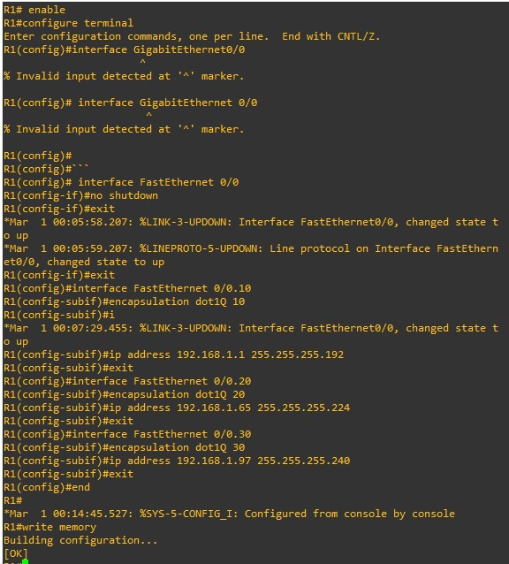

CISCO:
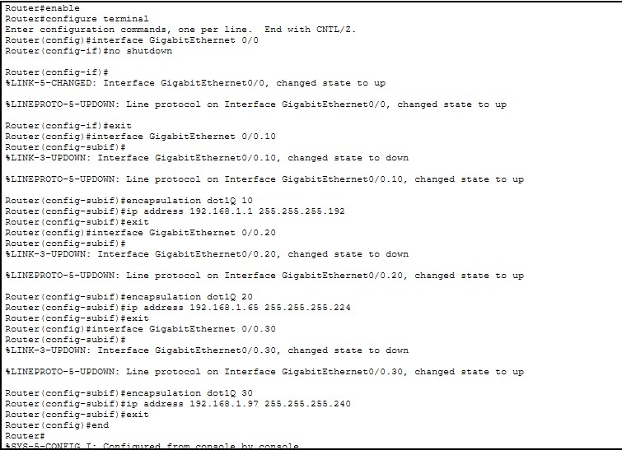
Switch Infrastructure & Port Mapping
Trunk Link Status: Switchports connecting Switch1 to Switch2, and Switch1 to Router R1 are explicitly configured as IEEE 802.1Q Trunks carrying tagged frames for active VLANs 10, 20, and 30.
Switch# show interface trunk
Port Mode Encapsulation Status Native vlan
Fa0/24 on 802.1q trunking 1
Port Vlans allowed on trunk
Fa0/24 1-1005
Port Vlans allowed and active in management domain
Fa0/24 1,10,20,30
Network Topolgy
The topology below shows one Cisco 2911 router connected to two Cisco 2960 switches using trunk links. Three VLANs were created: VLAN 10 (Sales), VLAN 20 (IT), and VLAN 30 (HR). Each VLAN has two PCs, one connected to Switch1 and the other connected to Switch2. The switches communicate through a trunk link, and the router provides communication between different VLANs using Router-on-a-Stick configuration. The network was implemented and tested in Cisco Packet Tracer and GNS3.
GNS3
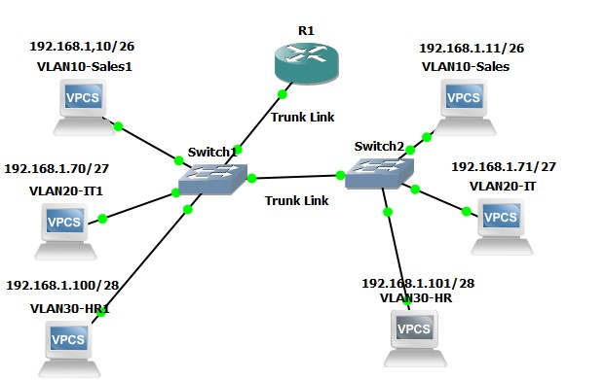
CISCO
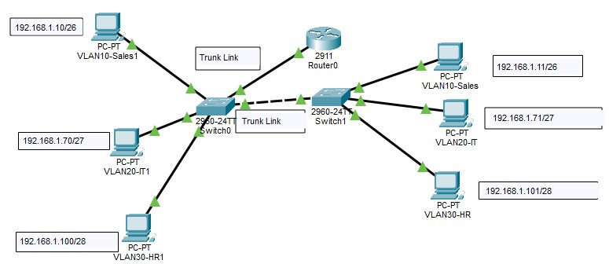
Ping Test:
Ping tests were performed to check the network connectivity. PCs in the same VLAN but connected to different switches communicated successfully, confirming that the trunk link between Switch1 and Switch2 was working correctly. Ping tests were also performed between different VLANs, and the successful results confirmed that the Router-on-a-Stick configuration was routing traffic between VLAN 10 (Sales), VLAN 20 (IT), and VLAN 30 (HR). This verified that the VLAN configuration, trunk links, IP addressing, and router configuration were working properly.
GNS3:
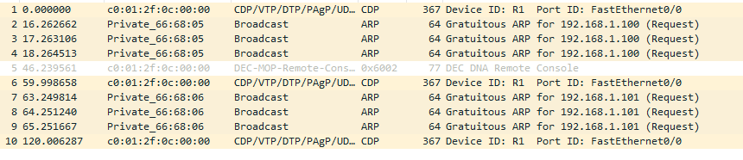
CISCO:
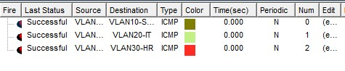
Challenges Faced & Solutions:

Challenge 1: VLSM Base Network Capacity Conflict
During the VLSM design, the original 192.168.0.0/23 network in Scenario D was not large enough to accommodate all required subnets, especially the 300-host student network.
Solution:
The subnet requirements were recalculated, and the base network was expanded to 192.168.0.0/22, providing sufficient address space for all departments without overlapping.

Challenge 2: Router-on-a-Stick Configuration
Initially, devices in different VLANs could not communicate because the router sub-interfaces and VLAN encapsulation were not configured correctly.
Solution:
The router was configured with 802.1Q sub-interfaces for VLAN 10, VLAN 20, and VLAN 30, and the correct gateway IP addresses were assigned. This enabled successful inter-VLAN communication.

Challenge 3: VLAN Trunk Configuration
At first, VLAN traffic was not passing correctly between Switch1 and Switch2 because the trunk configuration was incomplete.
Solution:
The trunk ports were configured with IEEE 802.1Q trunking, and the allowed VLAN list (10, 20, and 30) was configured on both switches. The configuration was verified using show interfaces trunk and show vlan brief commands.
Key Learning Outcomes
- Learned how to perform FLSM and VLSM subnetting for efficient IP address allocation and reduced address wastage.
- Learned how to calculate network addresses, subnet masks, usable host ranges, and broadcast addresses for different subnet sizes.
- Learned how to create VLANs (Sales, IT, and HR) and assign access ports on Cisco switches.
- Learned the difference between access ports and trunk ports, and how IEEE 802.1Q trunking allows multiple VLANs to communicate over a single link.
- Learned how to configure Router-on-a-Stick using router sub-interfaces for inter-VLAN routing.
- Learned how to configure and verify VLANs, trunk links, and router configurations using commands such as show vlan brief, show interfaces trunk, and show running-config.
- Verified both intra-VLAN and inter-VLAN communication using ping tests in Cisco Packet Tracer and GNS3.
- Improved practical skills in enterprise network design, IP address planning, troubleshooting, and network verification.
Conclusion:
This task provided practical experience in FLSM and VLSM subnetting, VLAN configuration, and Router-on-a-Stick implementation using Cisco Packet Tracer and GNS3. A total of 10 FLSM subnetting problems and 5 VLSM design scenarios were completed to develop efficient IP addressing schemes and minimize IP address wastage. Three VLANs (Sales, IT, and HR) were created and assigned to separate access ports on two Cisco 2960 switches connected through IEEE 802.1Q trunk links, while a Cisco 2911 router was configured with sub-interfaces to provide inter-VLAN communication.
During the implementation, challenges such as VLSM address planning, trunk configuration, and Router-on-a-Stick setup were successfully resolved. The complete network was verified using show vLAN brief, show interfaces trunk, show running-config, and ping tests. The successful test results confirmed proper VLAN segmentation, correct trunk operation, and successful communication within and between VLANs. Overall, this project strengthened practical knowledge of subnetting, IP address planning, VLAN implementation, inter-VLAN routing, network verification, and enterprise network design, providing valuable hands-on experience in configuring and troubleshooting modern computer networks.

